Chapter 4
Design

  - Table Relationship Diagram

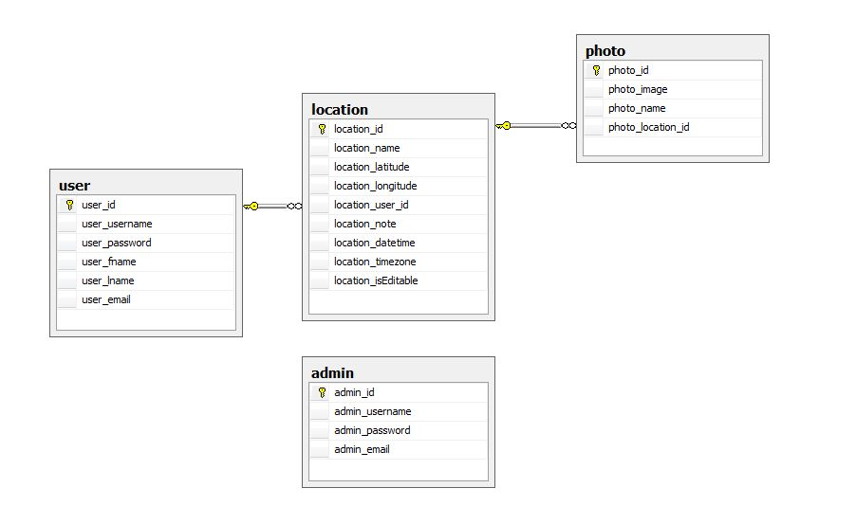

Figure 4.1 : Table Relationship Diagram

  - Data Dictionary

- Admin

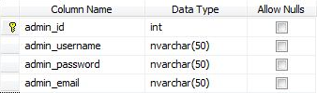
Figure 4.2 : Data Dictionary For Admin

- User

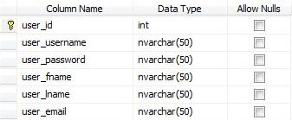
Figure 4.3 : Data Dictionary For User

- Location

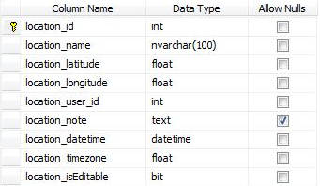
Figure 4.4 : Data Dictionary For Location

- Photo

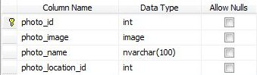

Figure 4.5 : Data Dictionary For Photo

  - ER Diagram
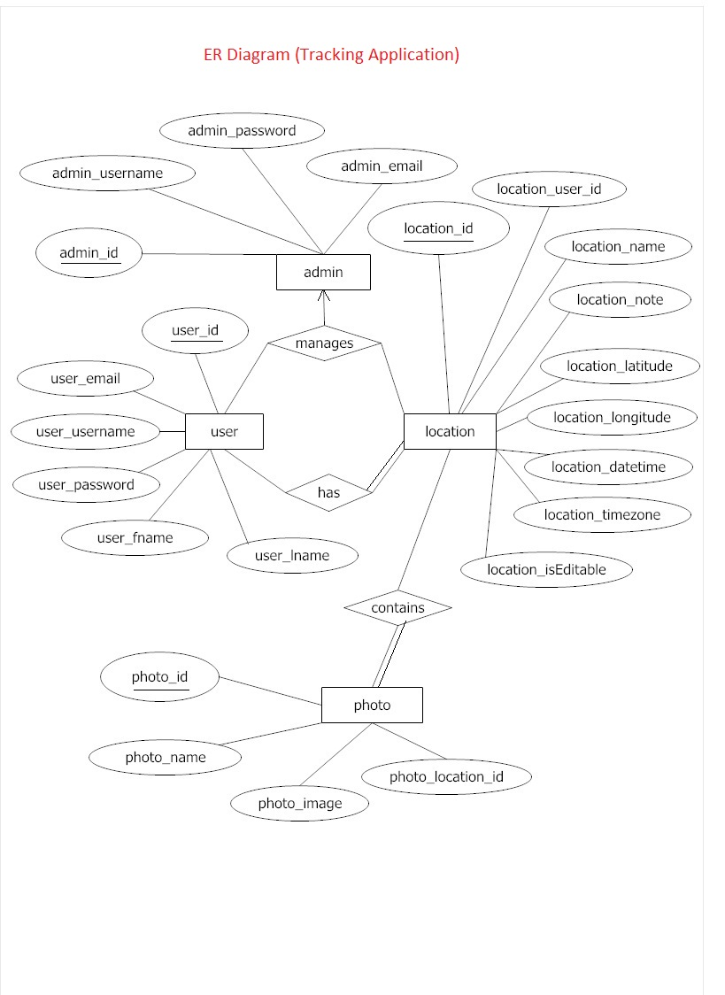
Figure 4.6 : ER Diagram

